Roobric Requirements Spec

# Introduction

## System overview

Many high school English classrooms receive student paper submissions through Google Docs. Teachers grade the paper using a rubric, also on Google Docs, and return the paper to the student. Roobric is a Google Doc add-on that will improve the rubric grading process for high school English courses. The add-on will be free to download from the Google App store. It will feature two modes of operation, one for teachers and one for students.

Teachers will use the add-on to link the associated rubric to a student’s paper. The linked rubric and additional features will be available in a sidebar on the Google Doc. After linking the paper, they will be able to associate comments with rubric categories, fill out the rubric, convert the rubric grade to a percentage grade, and insert the completed rubric into the student’s paper.

Students will use the add-on to review the graded results of their paper. The add-on will maintain the links established by the teacher for the student’ use. They will be able to see the links between comments and rubric categories, in addition to their final grade.

## Definitions, acronyms, and abbreviations

|  |  |
| --- | --- |
| **Term** | **Definition** |
| Teacher | High school English teacher |
| Student | High school student in an English course |
| Google Docs | Google’s interactive word document software |
| Rubric | Grading standards for a paper assignment |
| Paper | A student-submitted paper for an English assignment |

Table 1 - Definitions, acronyms, and abbreviations

# Overall Description

## Product perspective

Roobric will consist of two separate add-ons, one for teachers and one for students. The teacher add-on will be used to form the link between the rubric and paper, and grade the paper using the rubric. The student add-on will be used to review the graded paper.

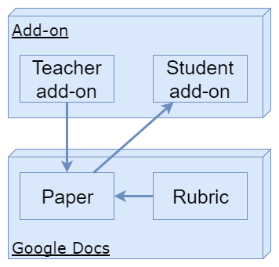The teacher add-on will be opened in the paper and link it to the rubric. A Google Doc document selector will be used to find the associated rubric with a familiar file selection window. In order for the student to review the results, we will need to save data for this add-on. We will store the link to the rubric, link between comments and categories, and final rubric results in the paper.

Figure 1 - Block diagram

The student add-on will read the links saved in the paper to load the necessary information for the student. The saved links will allow the add-on to highlight sections in the paper and rubric to make assist with the student’s review.

## Product functions

### Teacher add-on

The teacher add-on revolves around grading the paper with the assistance of the rubric. When the add-on is loaded while a paper is open it will prompt the teacher to associate a rubric with the paper. If one is already associated it will load that one. The rubric will be imported into the sidebar and grouped by the categories. The categories will be editable in case any adjustments need to be made to the imported results.

When a comment is inserted into the paper, the teacher will be able to associate the comment with a category from the rubric. This action will form a link between the comments and sections of the rubric. Selecting a category in the rubric sidebar will highlight existing comments linked to that category. Similarly, selecting a linked comment will highlight the rubric section associated to that comment.

After reviewing the paper, the grades can be entered into the rubric on the sidebar. Once the all of the sections of the rubric are graded the rubric score will be converted into a grade percentage. The finalized rubric can be submitted and inserted into the bottom of the google document. If google classroom is used to manage grades, the grade can be imported into google classroom from the document.

### Student add-on

The student add-on revolves around the review of their graded assignment. When the add-on is opened in the paper, it checks if a completed rubric has been submitted for their assignment. If there is one, it is pulled into the sidebar along with the grades for them to review.

Similar to the teacher’s add-on, the student can select comments or rubric categories to view the related information. Selecting a category in the rubric sidebar will highlight existing comments linked to that category. Selecting a linked comment will highlight the rubric section associated to that comment.

## User characteristics

Both the students and teachers will be experienced in using google docs in a classroom environment. However, they may not be experienced with using custom add-ons. They will have access to both computers and internet while in school, but outside of school they may have limited access.

## Constraints, assumptions, and dependencies

The imported rubric will be assumed to be a table following a standard format. Specifically the first column, except for the first row, will list the categories of the rubric. These categories could be brief or detailed. The first row, except for the first and last column, will list the point score for the categories. The other cells in the table will contain descriptions of the different point scores for the category.

|  |  |  |  |  |  |  |
| --- | --- | --- | --- | --- | --- | --- |
| **Reading and Writing Standards** | **0**  **(50%)** | **1**  **(65%)** | **2**  **(75%)** | **3**  **(85%)** | **4**  **(100%)** | **Points** |
| **Thesis Statement**  The thesis statement makes a clear argument about the meaning of the poem as a whole.  (10 pts)  (W. 9-10.1A) | The thesis statement is unclear or missing.  (5) | The paper includes an ineffective thesis statement and does not attempt to make an argument about the meaning of the poem as a whole.  (6.5) | The paper uses a somewhat effective thesis statement and attempts to make an argument about the meaning of the poem as a whole.  (7.5) | The paper uses a strong thesis statement and and makes an argument about the meaning of the poem as a whole.  (8.5) | The paper uses a strong and sophisticated thesis statement that makes a clear argument about the meaning of the poem as a whole.  (10) |  |
| **Supporting Evidence**  Develop thesis and identified literary devices with well-chosen, relevant, and sufficient evidence from the poem.  (20 pts)  (RL.9-10.1) | The paper uses little evidence and does not effectively use quoted or paraphrased information.  (10) | The paper uses little evidence. Evidence is incorporated relying too heavily on direct quotes or paraphrased information, sometimes ineffectively.  (13) | The paper uses effective evidence.  Evidence is incorporated through the use of direct quotes and paraphrased information, though occasionally used ineffectively.  (15) | The paper uses well-chosen evidence incorporating it through the use of direct quotes and paraphrased information in an effective way.  (17) | The paper uses well-chosen, sophisticated evidences, incorporating it through the use of effective direct quotes and paraphrased information.  (20) |  |
| **Literary Devices and Analysis**  Develop thesis with analysis of   how the literary devices enhance the meaning of the work as a whole.  (20 pts)  (RL.9-10.4) | Literary devices were not identified and no analysis was attempted.  (10) | One or more literary devices were identified, but their development was not analyzed or related to the meaning of the poem as a whole. Primarily plot summary.  (13) | One or more literary devices were identified, but their contribution to the meaning of the work as a whole was not thoroughly analyzed.  (15) | Two or more literary devices were identified. Their contribution to the meaning of the work as a whole was analyzed, though not well-developed.  (17) | Two or more literary devices were identified. Their contribution to the meaning of the work as a whole was thoroughly analyzed.  (20) |  |
| **…** | … | … | … | … | … |  |

Table 2 - Sample rubric

# Specific Requirements

## User interface requirements

### Teacher interface

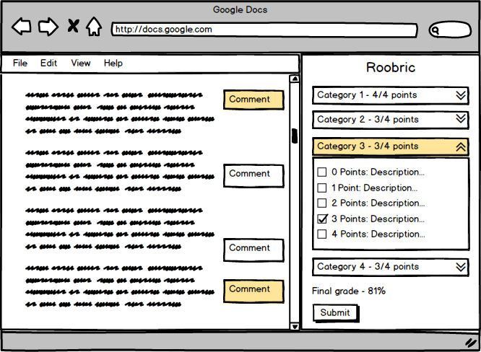In the teacher add-on the linked rubric will be displayed in a sidebar along with the google document. Each rubric category will be stored in its own drop down box. Selecting one of the categories from the sidebar will highlight it along with all associated comments. Additionally selecting a comment will highlight the associated rubric category.

Figure 2 - Teacher add-on

Double clicking on one of the categories will allow the teacher to edit the imported data. Expanding the box for each category will let the teacher select the points for each category. Once a point selection is made the category box will also display the point value. Once points are selected for each category the final grade will be displayed and the submit button will become enabled.

### Student interface

The student add-on will have a very similar user interface to the teacher add-on. The student will not have the submit button and will not be able to edit any of the category information.

## Functional requirements

**ID: FR1**

TITLE: Import rubric (new)

DESC: Upon initially opening the add-on in a paper, the teacher will be prompted to select a rubric from their google docs. The selected google doc will be used to populate the rubric in the sidebar.

RAT: In order to setup the paper for grading.

DEP: None

**ID: FR2**

TITLE: Import rubric (pre-existing)

DESC: When the add-on is opened in a paper which has already had a rubric imported, the rubric data from the last sessions will be loaded automatically.

RAT: In order to grade the paper over multiple sessions.

DEP: FR1

**ID: FR3**

TITLE: Modify imported rubric categories

DESC: Double clicking on one of the rubric categories on the sidebar will make that category editable. The teacher can modify the imported data as necessary.

RAT: In order to resolve any issues with importing.

DEP: FR1, FR2

**ID: FR4**

TITLE: Link comment to category

DESC: When entering a new comment, the user will be prompted to associate it with one the rubric categories. (Maybe instead of a prompt, allow the user to link through sidebar or right click menu)

RAT: In order to establish links between comments and categories.

DEP: FR1, FR2

**ID: FR5**

TITLE: Highlight associated rubric category

DESC: Selecting a comment that is associated with a rubric category will highlight the comment and the associated rubric category.

RAT: In order to improve reviewing grading.

DEP: FR1, FR2, FR4

**ID: FR6**

TITLE: Highlight associated comments

DESC: Selecting a rubric category that is associated with any comments will highlight the comments and the associated rubric category.

RAT: In order to improve reviewing grading.

DEP: FR1, FR2, FR4

**ID: FR7**

TITLE: Show/hide rubric scores

DESC: Selecting the arrows by a rubric category will display the point scores and their descriptions.

RAT: In order to see point options for each rubric category.

DEP: FR1, FR2

**ID: FR8**

TITLE: Modify imported rubric point scores

DESC: Double clicking on one of the rubric point scores on the sidebar will make that point score editable. The teacher can modify the imported data as necessary.

RAT: In order to resolve any issues with importing.

DEP: FR1, FR2

**ID: FR9**

TITLE: Select point score

DESC: Selecting the checkbox for one of the rubric point scores for that category will assign that point score to that category. This will display the point score on the header for that category.

RAT: In order to grade the paper.

DEP: FR1, FR2

**ID: FR10**

TITLE: Display percentage grade

DESC: When rubric scores have been selected for every category display the percentage grade.

RAT: In order to grade the paper.

DEP: FR1, FR2, FR9

**ID: FR11**

TITLE: Modify percentage calculation

DESC: Double clicking on the percentage grade will let the user modify how the grades are calculated. (maybe this can be setup in the rubric)

RAT: In order to grade the paper.

DEP: FR1, FR2, FR9

**ID: FR12**

TITLE: Submit rubric

DESC: Pressing the submit button will mark the rubric as submitted for the paper.

RAT: In order to mark grading complete.

DEP: FR1, FR2, FR9

**ID: FR13**

TITLE: Import rubric into paper

DESC: When pressing submit a copy of the rubric will appended to the paper.

RAT: In order to allow students to review results without add-on.

DEP: FR1, FR2, FR9, FR12

**ID: FR14**

TITLE: Send score to google classroom

DESC: When pressing the submit button also send the school to google classroom.

RAT: In order to improve grading workflow for teacher.

DEP: FR1, FR2, FR9, FR12

**ID: FR15**

TITLE: Import rubric (submitted)

DESC: When opening the student version of the add-on, if a rubric has been submitted for the paper it will be loaded into the sidebar.

RAT: In order to allow student to review grading

DEP: FR1, FR2, FR9, FR12

## Performance requirements

**ID: PR1**

TITLE: Import rubric

TIME: < 10 seconds

DESC: The initial importing of the rubric will occur when the add-on is loaded and will be accompanied by loading icon. This can take up to several seconds since the user will be transitioning to a new workflow.

**ID: PR2**

TITLE: Link comment to category

TIME: < 1 seconds

DESC: Comments may be linked to a category when it is initially created. Since a new text field is being loaded this doesn’t need to be instantaneous.

**ID: PR3**

TITLE: Highlighting associated categories and comments

TIME: < 0.1 seconds

DESC: During the review process users will be selecting categories and comments to see how they are connected. This should be an instantons action to help the user establish these connections.

## System attributes

### Reliability

The data entered by the teacher into the rubric and comments should not be able to be removed except by them. This is necessary to ensure accurate grading.

### Availability

This add-on should be available 24/7 since google docs is always available and teachers and students may be accessing papers at any time of the day.

### Security

When using the add-on only teachers should be able to edit the rubric scores for the paper. Students shouldn’t be able to edit their results and should only be able to see the results for their own paper.

# Prioritization and Release Plan

## Frist release – Essential features

|  |  |  |
| --- | --- | --- |
| **Feature ID** | **Title** | **Estimate (hours)** |
| FR1 | Import rubric (new) | 2 |
| FR2 | Import rubric (pre-existing) | 4 |
| FR7 | Show/hide rubric scores | 1 |
| FR9 | Select point score | 1 |
| FR12 | Submit rubric | 2 |
| FR15 | Import rubric (submitted) | 1 |
| PR1 | Import rubric | 1 |

## Second release – Primary features

|  |  |  |
| --- | --- | --- |
| **Feature ID** | **Title** | **Estimate (hours)** |
| FR4 | Link comment to category | 4 |
| FR5 | Highlight associated rubric category | 4 |
| FR6 | Highlight associated comments | 4 |
| FR3 | Modify imported rubric categories | 1 |
| FR8 | Modify imported rubric point scores | 1 |
| FR13 | Import rubric into paper | 1 |
| PR2 | Link comment to category | 1 |
| PR3 | Highlighting associated categories and comments | 1 |

## Third release – Auxiliary features

|  |  |  |
| --- | --- | --- |
| **Feature ID** | **Title** | **Estimate (hours)** |
| FR10 | Display percentage grade | 2 |
| FR11 | Modify percentage calculation | 2 |
| FR14 | Send score to google classroom | 8 |